H.T No
Regulations:
A22

Sreenidhi Institute of Science and Technology
(An Autonomous Institution)
Code No:9HC11 Date: 21-January-2025 (FN)

B.Tech I-Year I- Semester External Examination, January-2025 (Regular & Supplementary)
MATRIX ALGEBRA AND CALCULUS (Common to ALL)

Time: 3 Hours Max.Marks:60

Note: a) No additional answer sheets will be provided.
b) All sub-parts of a question must be answered at one place only, otherwise it will not be valued.
c) Missing data can be assumed suitably.
Bloom's Cognitive Levels of Learning (BCLL)

Remember | L1 | Apply | L3 | Evaluate | L5
Understand | L2 | Analyze | L4 | Create | L6

Part - A Max.Marks: 6x2=12

Answer all QUESTIONS, EACH QUESTION CARRIES 2 MARKS.

 |  | BCLL | CO(s) | Marks
1 | If 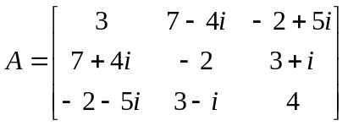then show that A is Hermitian matrix. | L1 | CO1 | [2M]
2 | Find the sum and product of the Eigen values of 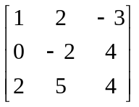 | L1 | CO2 | [2M]
3 | Define positive definite and indefinite quadratic forms. | L1 | CO3 | [2M]
4 | State Rolle's theorem. | L1 | CO4 | [2M]
5 | Find the integrating factor of 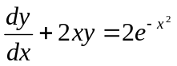 | L2 | CO5 | [2M]
6 | Solve D(D –1) y = 0 | L1 | CO5 | [2M]

Part – B Max.Marks: 6x8=48
ANSWER ALL QUESTIONS. EACH QUESTION CARRIES 8 MARKS.

 |  | BCLL | CO(s) | Marks
7. | i) Find the inverse of a matrix 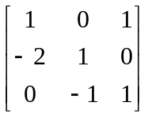using Gauss-Jordan method.  ii) Verify the matrix 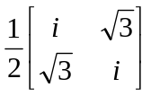is unitary or not. | L2 | CO1 | [8M]
 | OR
8 | Test for consistency and solve 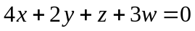, 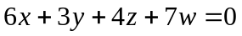 and 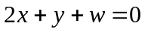 | L3 | CO1 | [8M]
9. | Find the Eigen values and Eigen vectors of 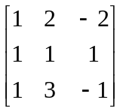 | L2 | CO2 | [8M]
 | OR
10 | Verify Cayley-Hamilton theorem for the matrix 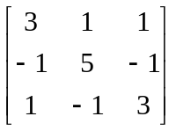 and hence find A⁻¹. | L3 | CO2 | [8M]
11 | Reduce the quadratic form 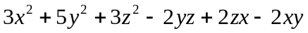 to canonical form by orthogonal reduction. | L4 | CO3 | [8M]
 | OR
12 | i) Find the rank, index and signature of 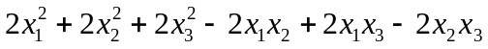  ii) Reduce the quadratic form 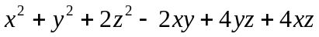 to canonical form by Lagrange’s reduction. | L3 | CO3 | [8M]
13 | Prove that for 0<a<b<1, 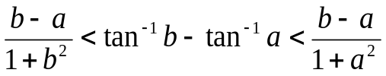  and hence show that 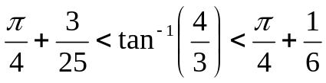 | L3 | CO4 | [8M]
 | OR
14 | i) Verify the results of Cauchy’s mean value theorem for the functions  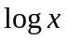 and 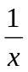 in (0, e).  ii) Obtain Taylor’s series expansion of 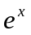 in powers of 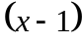 | L2 | CO4 | [8M]
15 | i) Solve 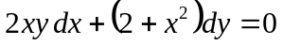  ii) The rate at which bacteria multiply is proportional to the instantaneous number. If the original number doubles in two hours, in how many hours will it triple? | L2 | CO5 | [8M]
 | OR
16 | Solve 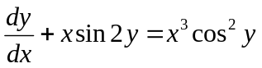 | L2 | CO5 | [8M]
17 | i) Solve 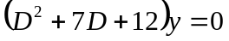 .  ii) Solve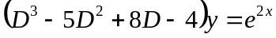. | L3 | CO5 | [8M]
 | OR
18 | Using method of variation of parameters, solve y'' + y = tanx. | L2 | CO5 | [8M]

-- 00 -- 00 –

